**Reservoir Continuum Days Packing List**

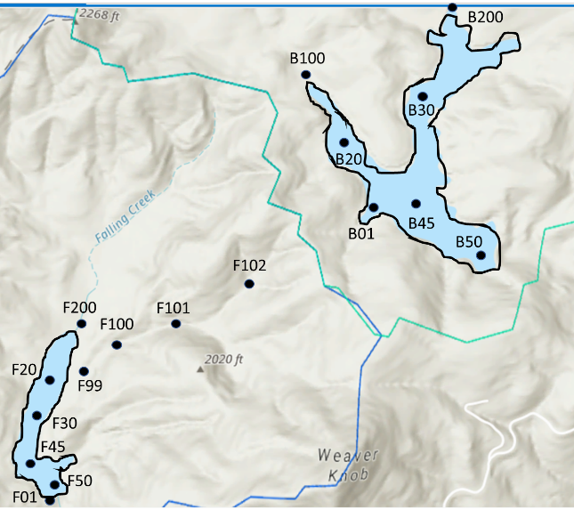

**Sampling Bag Contents**

*Site Bags*  
-2 labeled total nutrients bottles  
-2 labeled soluble nutrients bottles  
-2 labeled EEMs vial   
-2 GHG vials  
-BDOC bottle for select sites (B100, B20, B01, B50, F50, F30, F200, F99, F102)  
 *Label format: ResDate Site Sample Rep  
 Example label: F29Apr19 102 T R1*

*Supplies Bag*  
-acid-washed syringes (>10)  
-acid-washed filter cartridges (loaded with combusted filters)   
-extra combusted GF/F filters  
-extra regular GF/F filters  
-forceps

**FCR   
10 Sites: F102, F101, F100, F99, F200, F20, F30, F45, F50, F01**

*Discharge*  
F200  
-simple flowmeter   
-meter stick   
-measuring tape  
-metal rods to mark stream width   
F01, F99-102  
- 6 50g bags of salt  
-calibration standards  
-graduated cylinder  
-bucket

*Sensors*  
-DO meter B (Lot code 17J2)  
-Conductivity meter 2 (Lot code 18B1)

10 Site Bags (see above sites)  
1 ‘Supplies bag’  
10 Labeled Chlorophyll Bottles

Cooler with ice (prepped day of)  
2 field notebooks (field sheets + pencils)  
2-3 lifejackets

**BVR  
7 Sites: B100, B200, B20, B30, B45, B50, B01**

*Discharge @ B100 and B200*  
- 2 25g bags of salt  
-calibration standards  
-graduated cylinder  
-bucket  
-measuring tape

*Sensors*  
-YSI  
-Conductivity meter 1 (Lot code 17L1)

7 Site Bags (see above sites)  
1 ‘Supplies bag’  
7 Labeled Chlorophyll Bottles

Cooler with ice (prepped day of)  
Notebook (field sheets + pencils)  
Toolbox  
First aid kit  
2-3 lifejackets

Boat supplies: charged battery, gas, boat hitch, boat keys from WVWA